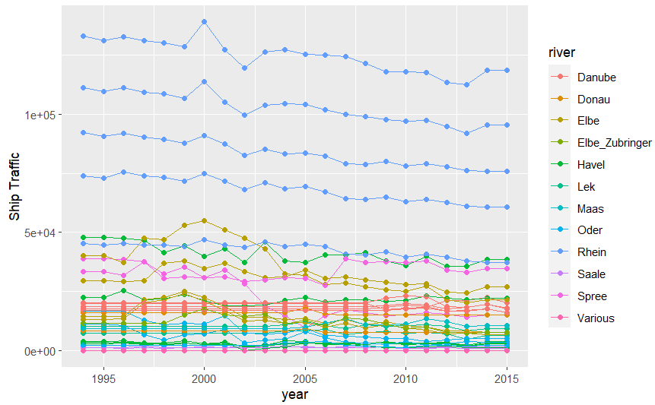

Supplemental Figure 1 – Vessels per year passing through specific locks, from 1992 to 2015. Locks are color-coded by the river they are within.